Building Chatbot using

Google Dialogflow

Table of Contents

1. Architecture 3

1.1. Retrieval-based model 3

1.2. Architecture Google dialog flow chatbot 3

2. Google Dialog Flow 4

2.1. Introduction 4

2.2. Why choose Google Dialogflow 4

2.2.1. Delivers natural and productive conversations 4

2.2.2. Understands what users are saying 4

2.2.3. Works with many platforms 4

2.2.4. Support for various devices 4

2.2.5. Helps chatbots to speak 14+ languages 4

2.2.6. Performance tracking with an analytics tool 4

2.3. How do Chatbots work? 5

2.4. Build your first COVID 19 Chatbot 6

2.4.1. Workflow 6

2.4.2. Signup for Dialogflow account 7

2.4.3. Creating an Agent 8

2.4.4. Creating an Intent 11

2.5. Fullfillment 19

2.6. Integration with Facebook and telegram 19

2.7. Integrate the GoogleChatbot in Facebook 25

2.8. Integrate the GoogleChatbot in Telegram 27

2.9. Mail received details 31

1. Architecture
   1. Retrieval-based model

These models are much easy to build and provide more predictable responses. They make use of context in the conversation for selecting the best answer from a predefined list of messages that they got trained. It includes all the previous discussions and the saved variables

Figure : Retrieval-based model diagram

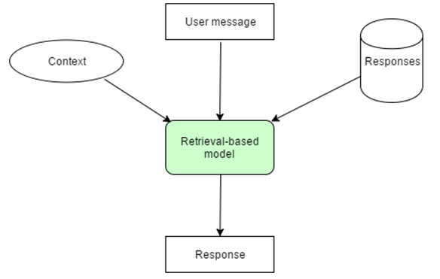

* 1. Architecture Google dialog flow chatbot

1. Google Dialog Flow
   1. Introduction

Google Dialogflow is a Google-owned developer of human-computer interaction technologies based on natural language conversations. It gives users a new option to interact with the product by building voice apps and chatbots powered by AI.

* 1. Why choose Google Dialogflow
     1. Delivers natural and productive conversations

It has built-in natural-language processing features and teaches artificial intelligence (AI) to the chatbot, thereby enabling it to process conversation naturally.

* + 1. Understands what users are saying

Machine learning makes Dialogflow is intelligent enough to predict the hidden intention expressed in the input language. A Dialogflow chatbot map’s the user query with the database available with its backend server.

* + 1. Works with many platforms

Chatbot developed using Dialogflow supports many platforms, and thus Google Chatbot development, businesses can target a wider audience with the least effort.

* + 1. Support for various devices

Dialogflow helps with creating a device-antagonistic chatbot. Thus, it engages with users on wearables, phones, cars, speakers, and other smart devices. It helps to connect the businesses with their prospects or customers anywhere, anytime.

* + 1. Helps chatbots to speak 14+ languages

Dialogflow supports many languages like Brazilian Portuguese, Chinese, English, Dutch, French, German, Italian, Japanese, Korean, Portuguese, Russian, Spanish, and Ukrainian.

* + 1. Performance tracking with an analytics tool

Similar to mobile app analytics, we can track the performance of the chatbots. The integrated analytics tool can read usage patterns, latency issues, and high- and low performing intents

* 1. How do Chatbots work?

Figure : Chatbots workflow diagram

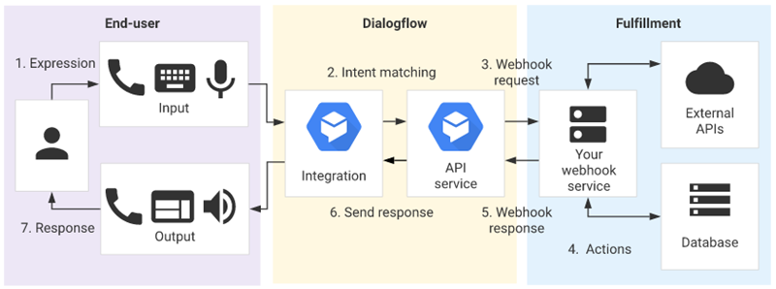

Image Courtesy: <https://cloud.google.com/dialogflow/docs/basics>

**Steps**:

1. The user sends a text or voice message from a device or an App
2. The App or the Device transfers the data to Dialogflow
3. The message is categorized and matched to a corresponding intent
4. We define actions for each Intent in fulfillment (Webhook).
5. When Dialogflow finds a specific intent, the webhook will use external APIs to find a response from external databases.
6. The external databases send back the required information to the webhook.
7. Webhook sends a formatted response to the intent.
8. Intent generates actionable data according to different channels.
9. Data go to output Apps or Devices attached
10. The user would get a text/image/voice as a response.
    1. Build your first COVID 19 Chatbot
       1. Workflow

Figure : Workflow diagram

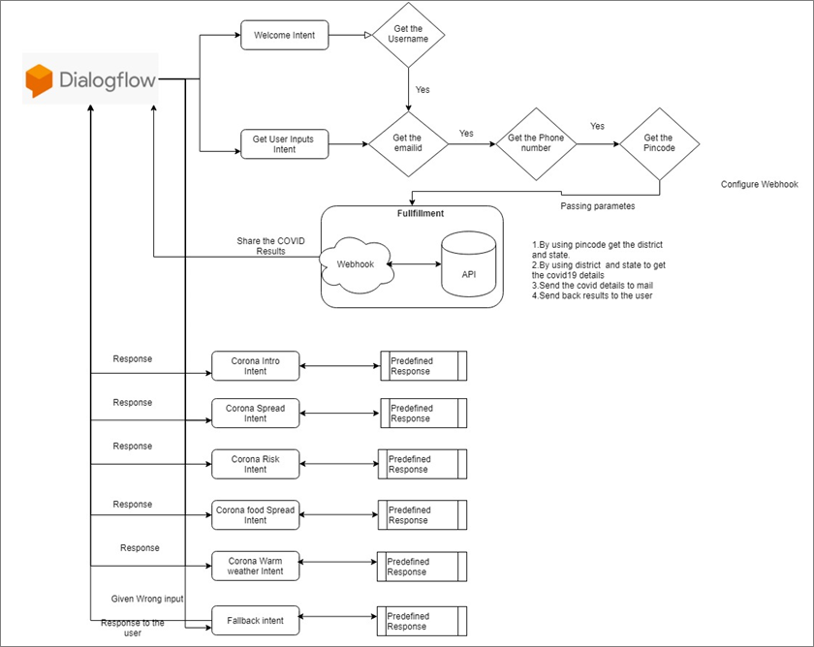

Figure : Workflow diagram

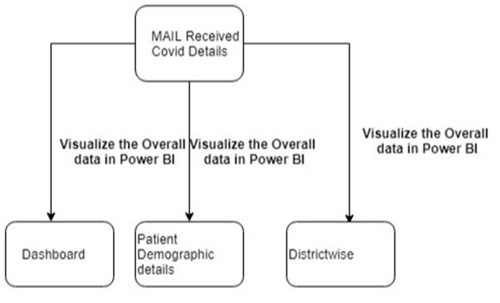

* + 1. Signup for Dialogflow account

Prerequisite:

A Google account is required for connecting to Google Dialogflow.

To Create Dialogflow account, do the following:

1. Create Dialogflow account by using the link (<https://dialogflow.com/>) and click on **Sign up for Free** and proceed with account creation.

Figure : Dialogflow Account screen

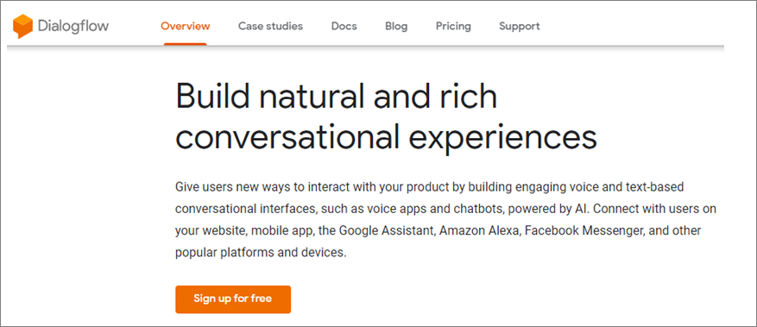

1. Click on **Sign-in with Google**.
2. Select your Google account and it will redirect to the Google Dialogflow home page. Click on **Go to console** in the upper right corner to navigate to the home page of Google Dialogflow.

Figure : Home (page) screen



* + 1. Creating an Agent

An agent is a virtual agent or bot that handles the conversation with end-users. We can design or build a Dialogflow agent to handle the different types of communications required by the system. These can be included in any app, product, or service and transform natural user requests into actionable data.

1. Log in to Dialogflow and click on **Create new agent** from the left menu.

Figure : Dialogflow screen

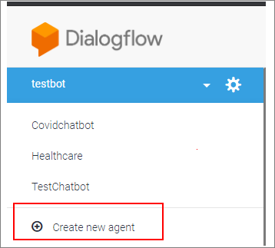

1. Provide the name of the agent and click on the **SAVE** button to create a new Agent.

Figure : New Agent screen

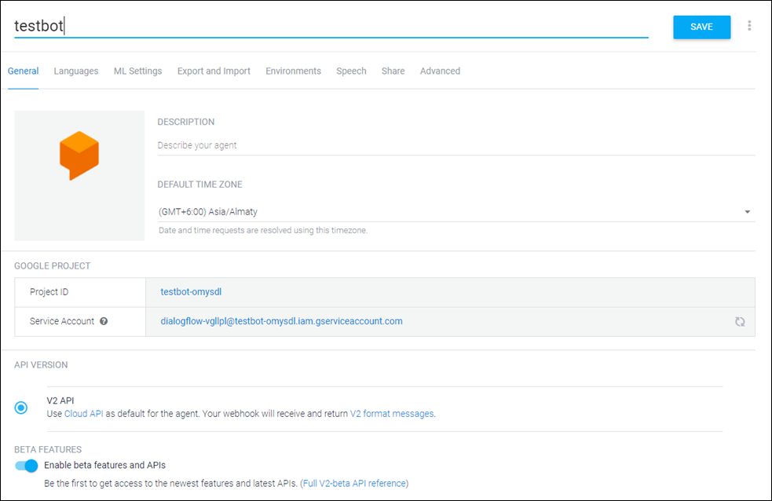

1. The Agent gets created and gets listed below the Dialogflow icon. If there are multiple agents, use the dropdown down button to select the Agent for editing or adding new data
2. Edit the Agent details using the setting icon

Figure : Edit Agent Details screen

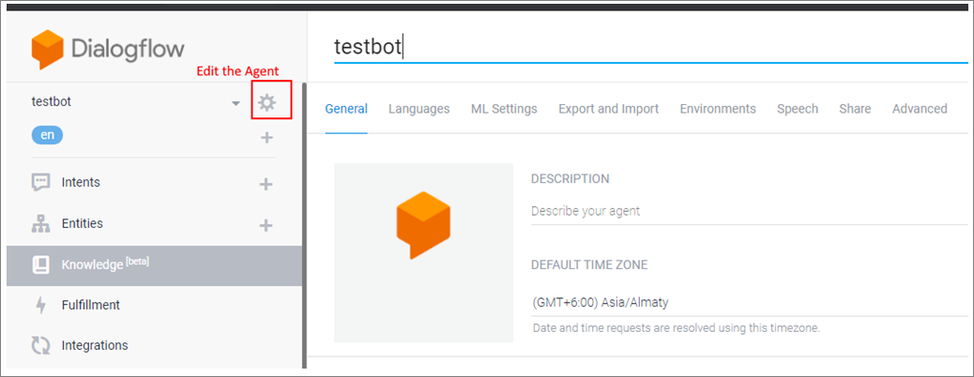

1. After agent is created, by default create the Welcome and Fallback intent

Figure : Welcome and Fallback Intent screen

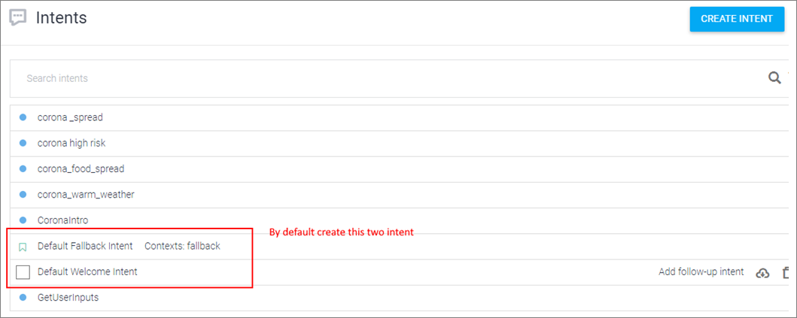

* + 1. Creating an Intent

To Create Intent, do the following

1. Open the Welcome intent and then create a new variable in output context. To carry this output information to next intent.
2. **Contexts** represent the current state of a user's request and allow your agent to carry information from one intent to another.

Figure : Default Welcome Intent screen

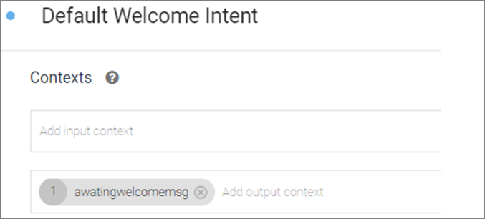

1. Under Events section, select **Welcome**.
2. Custom events are events that you define. You can invoke these events using either fulfillment or the API. For example, you might set a timed alert during a conversation, which invokes an event at a certain time. This event could trigger an intent that alerts the end-user about something.

Figure : Events screen

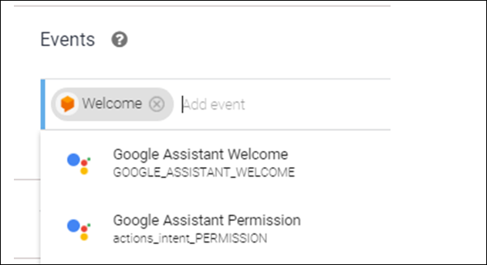

1. Click on **ADD TRAINING PHRASE** and then add Training phrases. Training phrases are examples of what users can say to match a particular intent. Adding numerous phrases with different variations and parameters will improve the accuracy of intent matching.

Figure : Training phrases screen

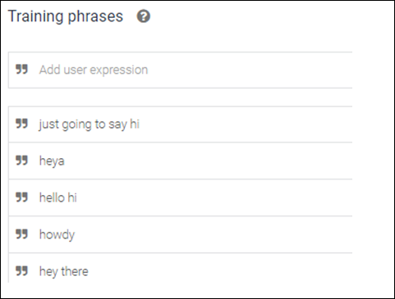

1. Add the below response in the **Default welcome intent**.

Figure : Responses screen

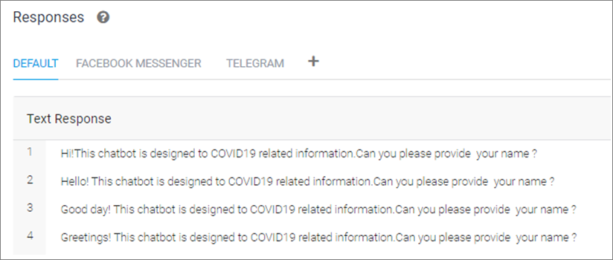

1. Create the intent to get the user inputs **GetUserInputs** and pass the input **AwaitingWelcomemsg.**

Figure : GetUserInputs screen

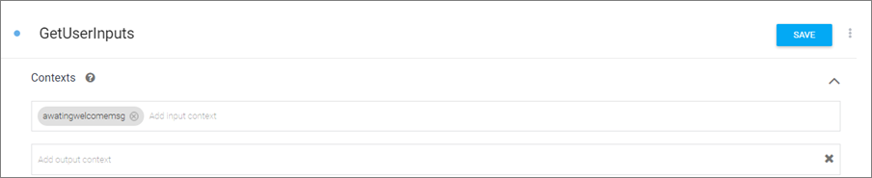

1. Under training phrases section to train the below pharses and also add the action parameters to get the user inputs.
2. Name, email ID, phone number, and pin code

Figure : Training Phrases screen

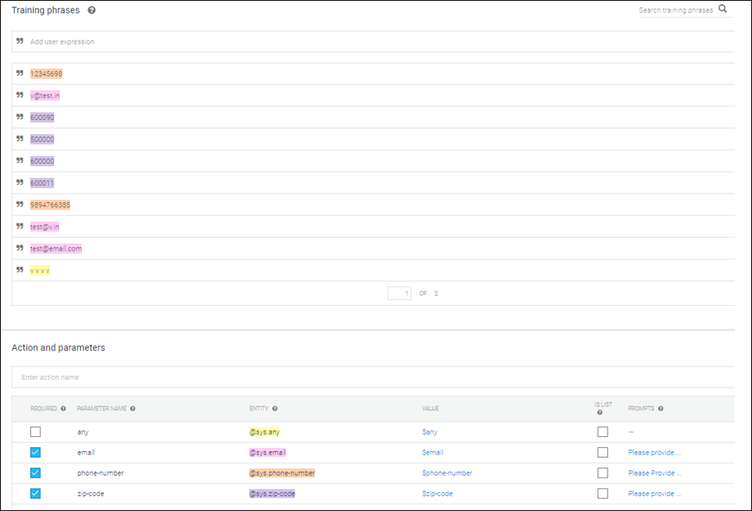

1. Enable the fulfillment in this intent and click save

Figure : Fulfillment screen

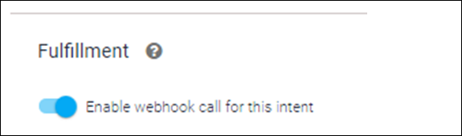

1. Create the following custom intents

Figure : Fulfillment screen



1. Create the **Corona intro** intent.

Figure : CoronaIntro screen

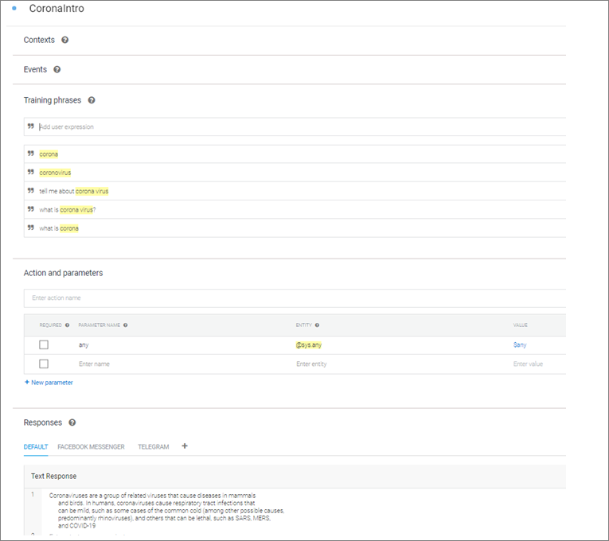

1. Create another intent **corona_food_spread**.

Figure : corona_food_spread screen

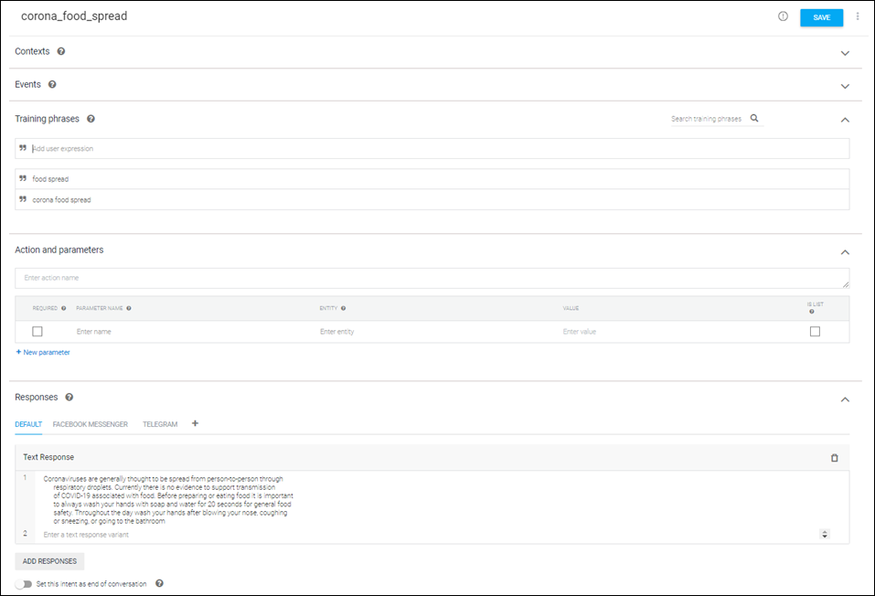

1. Create another intent for **Corona high risk**.

Figure : Corona high risk screen

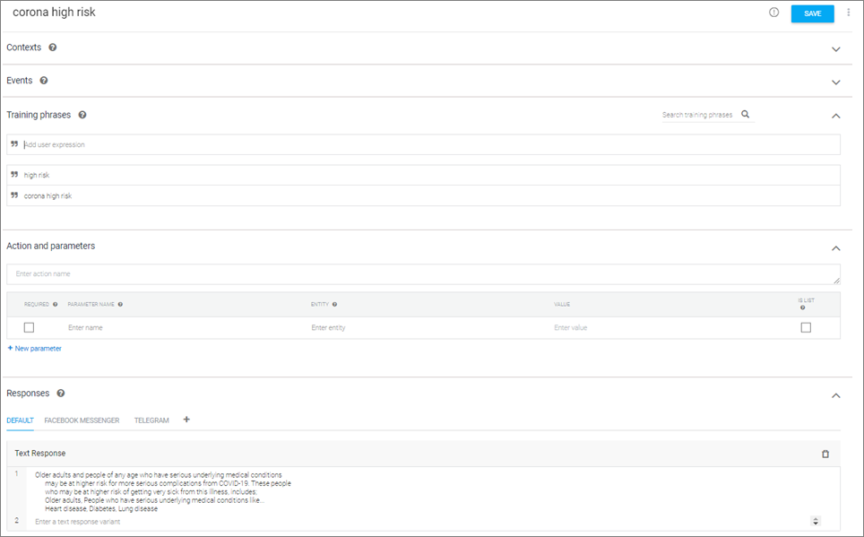

1. Modify the response in **Default Fallback Intent**.

Figure : Default Fallback Intent screen

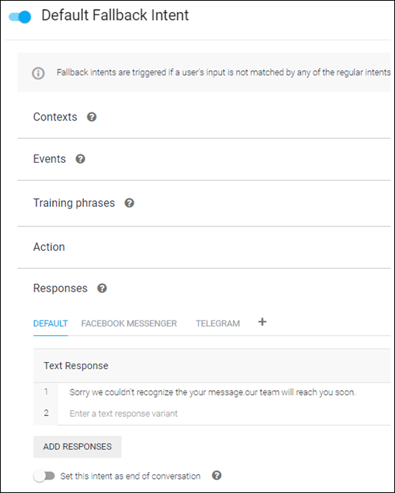

* 1. Fullfillment

1. In **Dialogflow** go to fulfillment to enable the webhook and configure the Deployed URL

Figure : Fullfillment screen

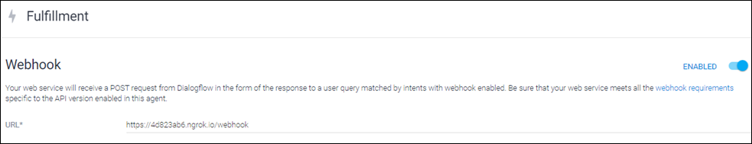

1. By using ngrok to deployed the URL in the local machine.

Figure : Local machine screen

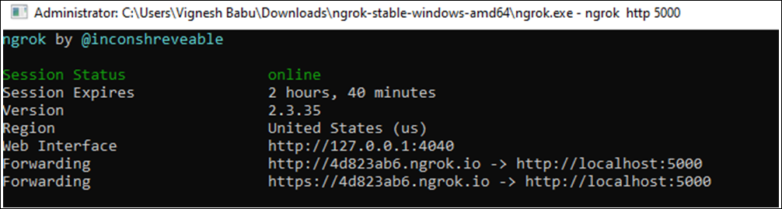

* 1. Integration with Facebook and telegram

1. Go to the integration section in the Dialogflow and enable Facebook & Telegram

Figure : Integrations screen

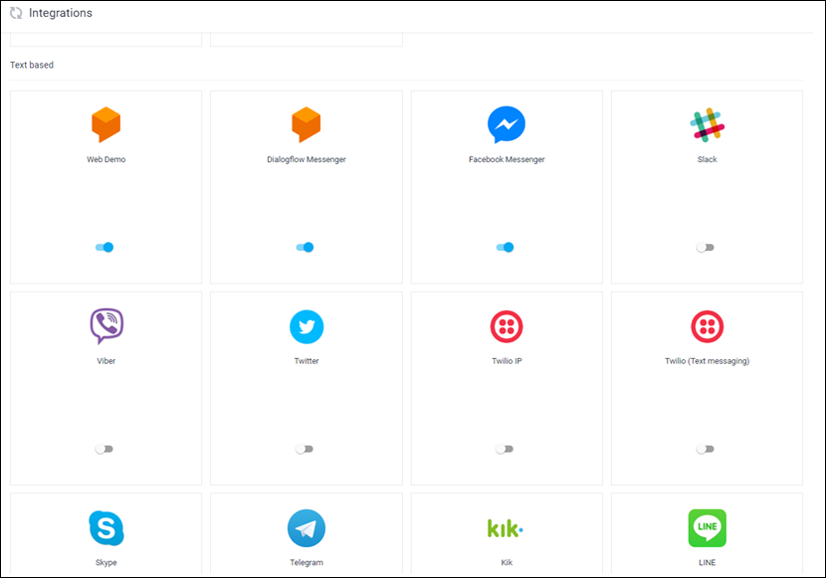

1. Enable in Facebook settings
2. Call back URL provided by dialogflow
3. Verify token – We need to remember this token

Figure : Integrations screen

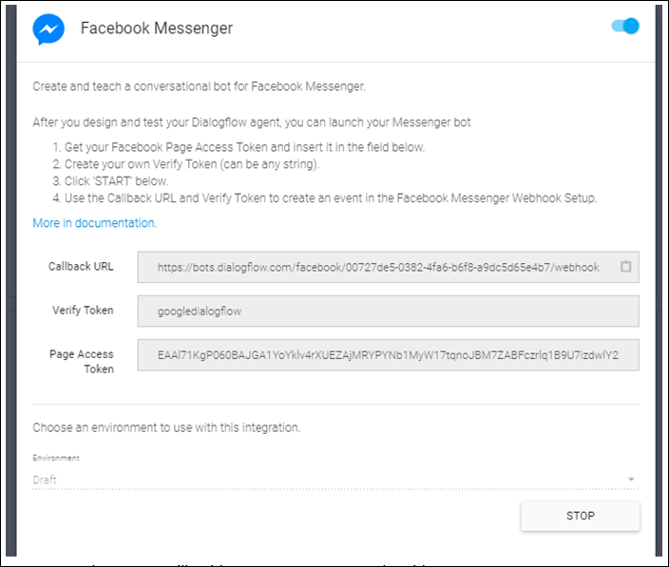

1. Page Access token – We will guide you to create a page token ID.
2. Go to <https://developers.facebook.com/> and sign in with face book account.
3. Sign in your account and then select the **MyApps**.

Figure : Facebook screen



1. Create a new App ID.

Figure : New App ID screen

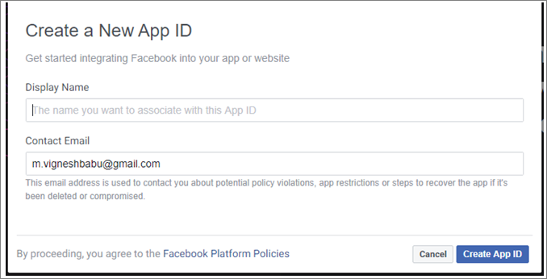

1. Select your App ID and go to home page.

Figure : App ID screen

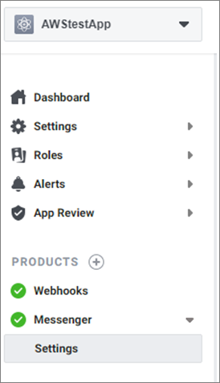

1. Go to messenger settings and under Access Tokens to create a new page and generate token.

Figure : Access Tokens screen

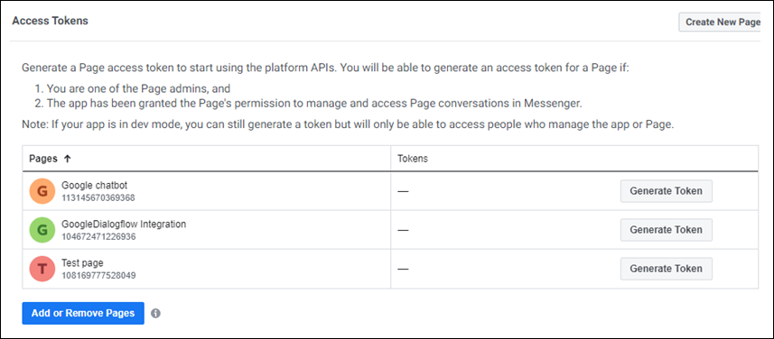

1. Generate the Tokens & configure this token id under Dialogflow integration.

Figure : Token Generated screen

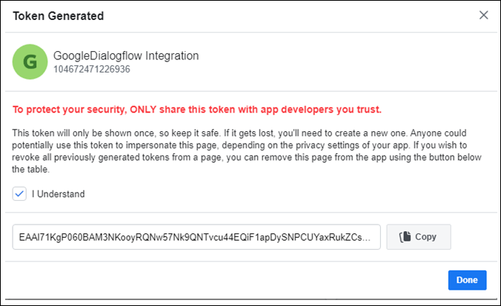

1. Configure the Webhook and page access token

Figure : Access Tokens screen

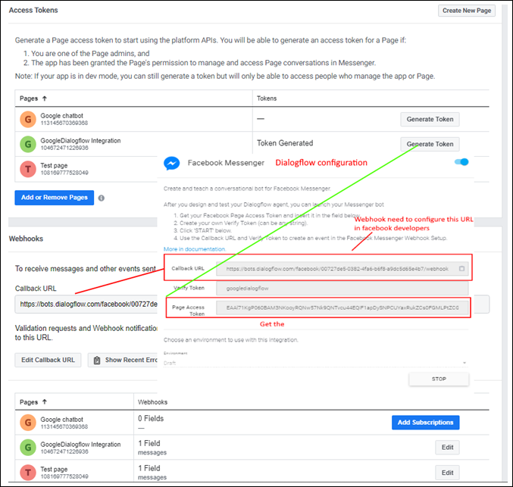

1. And then click save changes in the facebook developers
   1. Integrate the GoogleChatbot in Facebook

To Integrate the GoogleChatbot in Facebook, do the following:

1. Go to face book login and open the created page and click the send message.

Figure : Facebook screen

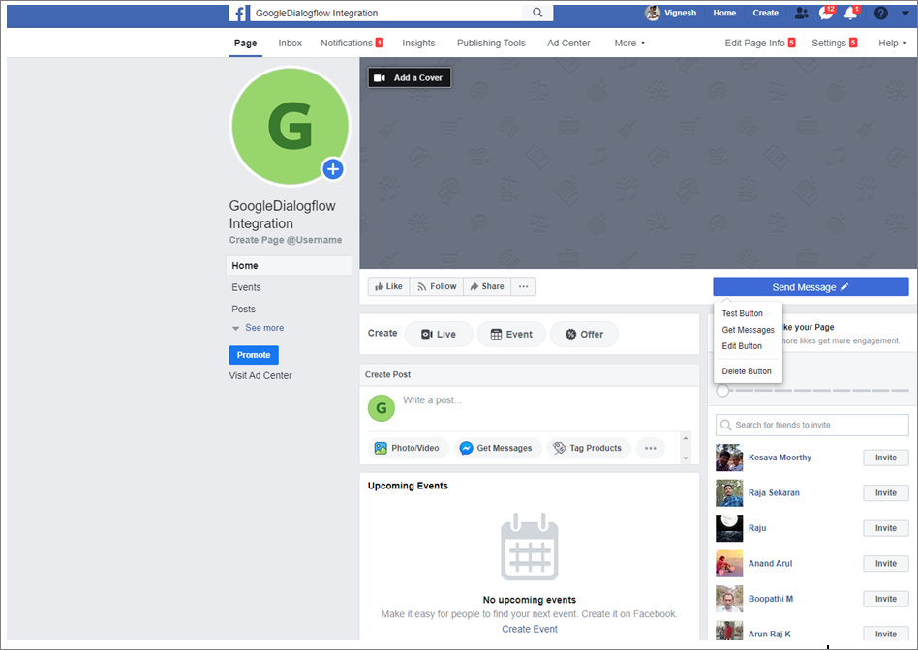

1. Click **Send Message** button and then select the send message under **Contact you** section.

Figure : Send Message screen

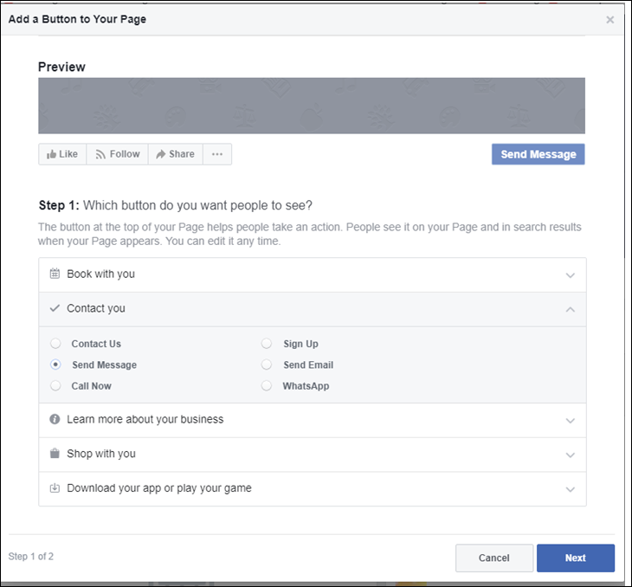

1. Integration screen

Figure : GoogleDialogflow Integration screen

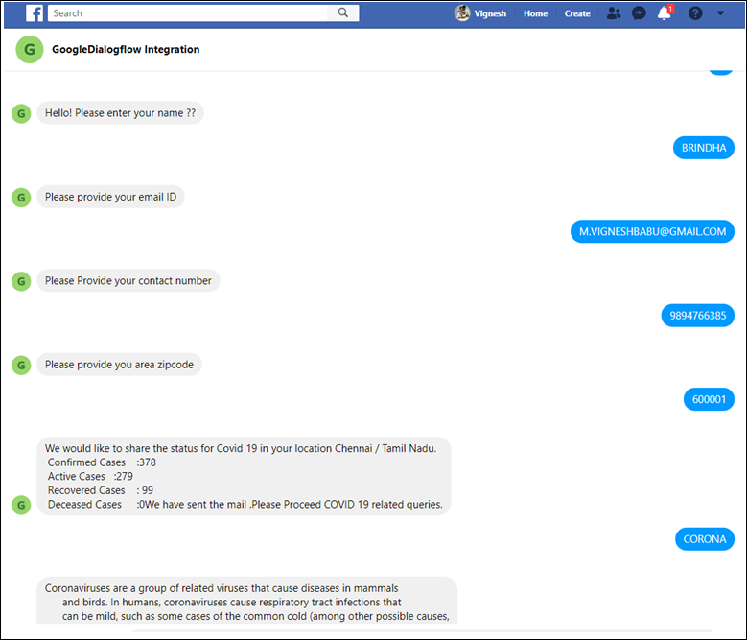

* 1. Integrate the GoogleChatbot in Telegram

1. Install the Telegram in you mobile
2. Go to “BotFather” bot in telegram
3. Please put command “/Start”

Figure : GoogleDialogflow Integration screen

|  |  |
| --- | --- |
|  |  |

1. After please above command to create a new bot “/newbot”
2. Choose the name of you bot ”Googlechatbot”
3. You will get the access key

“HTTP API”: **11121212:XXXXXXXXXXXXXXXXXXXXXX** - similar like key will generate in your mobile.

Figure : Telegram screen

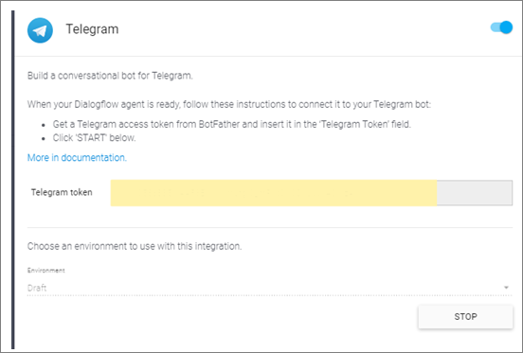

1. Integrated chatbot in Telegram

Figure : Chatbot screen

|  |  |  |
| --- | --- | --- |
|  |  |  |

* 1. Mail received details

1. View the below information in mail

Figure : COVID 19 Details in Mail screen

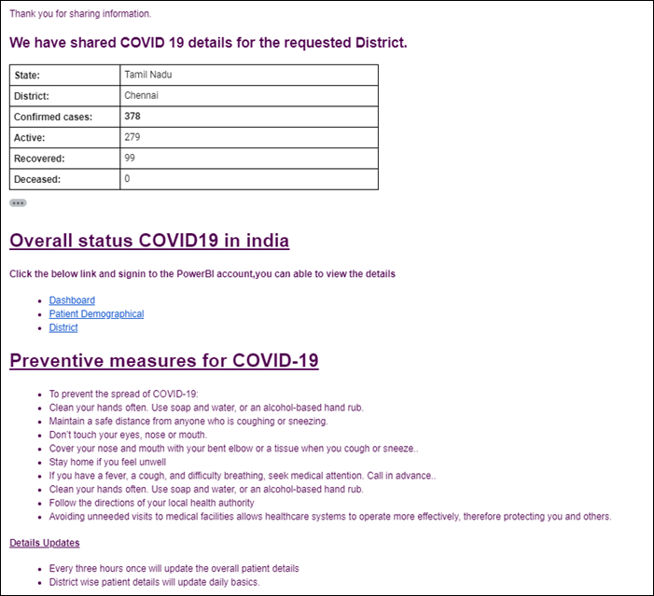

1. Overall status link
2. Need to login once for power BI
3. Patient demographical information
4. <https://app.powerbi.com/reportEmbed?reportId=c2f01126-ac5b-4485-89ad-5157b188e2b6&autoAuth=true&ctid=83654c9f-1ffc-46cb-a496-4dea88377b42&config=eyJjbHVzdGVyVXJsIjoiaHR0cHM6Ly93YWJpLWluZGlhLXdlc3QtcmVkaXJlY3QuYW5hbHlzaXMud2luZG93cy5uZXQvIn0%3D>
5. Please use above link to view patient demographics information

Figure : Patient Demographics Information screen

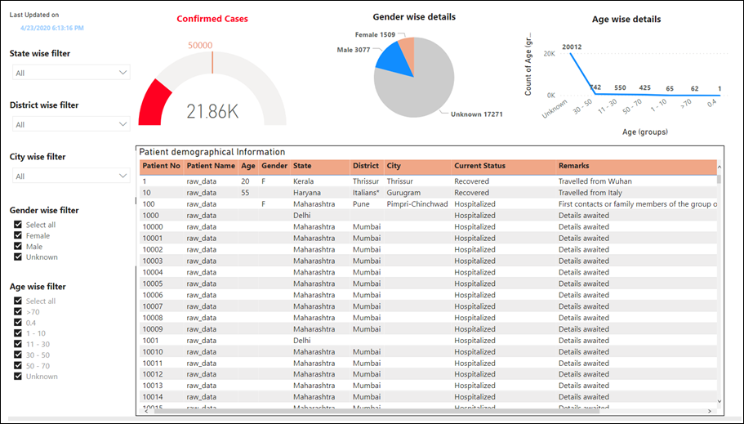

1. Statewise
2. <https://app.powerbi.com/reportEmbed?reportId=7305dc4e-0a86-4b9f-bbd8-fa917059fccc&autoAuth=true&ctid=83654c9f-1ffc-46cb-a496-4dea88377b42&config=eyJjbHVzdGVyVXJsIjoiaHR0cHM6Ly93YWJpLWluZGlhLXdlc3QtcmVkaXJlY3QuYW5hbHlzaXMud2luZG93cy5uZXQvIn0%3D>
3. Please use above link to view district wise information

Figure : District wise information screen

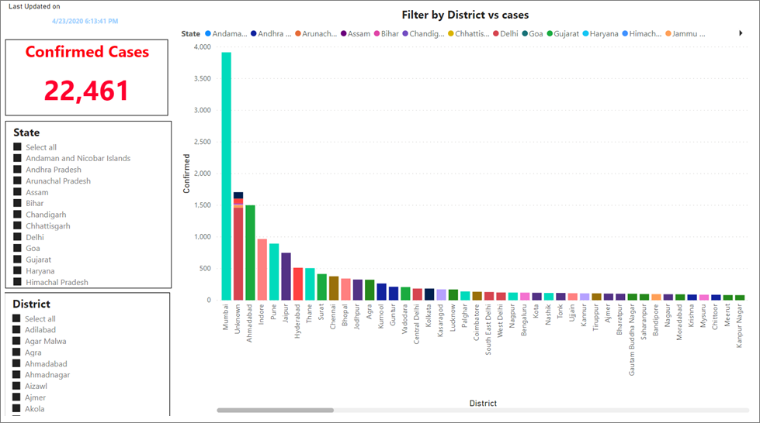

1. Dashboard Information

<https://app.powerbi.com/reportEmbed?reportId=99c6134e-0573-450e-9a8e-c54d9274fca1&autoAuth=true&ctid=83654c9f-1ffc-46cb-a496-4dea88377b42&config=eyJjbHVzdGVyVXJsIjoiaHR0cHM6Ly93YWJpLWluZGlhLXdlc3QtcmVkaXJlY3QuYW5hbHlzaXMud2luZG93cy5uZXQvIn0%3D>

Figure : Dashboard Information screen

